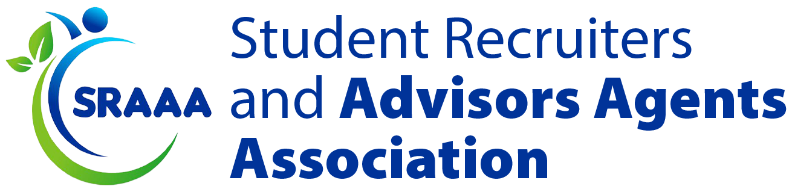
MEMORANDUM OF UNDERSTANDING (MoU) BETWEEN SRAAA & [UNIVERSITY NAME]
This Memorandum of Understanding (MoU) is entered into by and between the Student Recruitment Agents & Advisors Association (SRAAA), hereinafter referred to as "SRAAA," and [University Name], hereinafter referred to as "the University."

1. Purpose of the MoU
This MoU establishes a framework for collaboration between SRAAA and the University to:
- Ensure ethical student recruitment by connecting universities with SRAAA-certified recruitment agents in Nigeria.
- Protect Nigerian students studying at the University through legal, welfare, and advisory support.
- Enhance transparency, compliance, and best practices in international student admissions.

2. Areas of Cooperation
Both parties agree to collaborate on the following areas:
- Recruitment & Admission Support: The University will only engage with SRAAA-certified recruitment agents to admit Nigerian students.
- Verification & Monitoring: SRAAA will maintain a compliance database of verified agents, ensuring all recruitment is transparent and ethical.
- Student Protection & Welfare: The University agrees to support Nigerian students through:
  - Pre-departure orientation & guidance
  - 24/7 student support helpline
  - Legal and academic advocacy services
  - Accommodation & integration assistance
- Regular Compliance Audits: Both parties will conduct bi-annual evaluations to ensure adherence to agreed standards.

3. Responsibilities of SRAAA
SRAAA commits to:
- Maintain a list of certified recruitment agents, ensuring compliance with ethical recruitment standards.
- Provide training and development programs for recruitment agents working with the University.
- Offer legal, welfare, and emergency support for Nigerian students facing challenges abroad.
- Facilitate feedback mechanisms where students and universities can report recruitment issues.
- Assist with visa processing guidance and regulatory compliance for students.

4. Responsibilities of the University
The University commits to:
- Recognize and engage with SRAAA-certified recruitment agents for student admissions from Nigeria.
- Ensure a safe and supportive environment for Nigerian students studying at the institution.
- Provide legal and academic support for students in cases of disputes, discrimination, or academic challenges.
- Allow access to student affairs representatives for collaboration with SRAAA’s student welfare team.
- Participate in recruitment audits and compliance evaluations conducted by SRAAA.

5. Implementation & Monitoring
- A Joint Working Committee will be formed to oversee implementation.
- The University and SRAAA will review progress semi-annually and adapt processes as needed.
- Both parties agree to maintain open communication to address issues promptly.

6. Duration & Termination
- This MoU is valid for a period of [X] years from the date of signing.
- Either party may terminate the agreement with a 90-day written notice.
- Amendments to this MoU must be made in writing and mutually agreed upon.

7. Legal Standing
This MoU is non-binding but serves as a formal commitment to cooperation and ethical recruitment standards.

8. Signatures
This agreement is entered into on [Date] and shall be signed by authorized representatives from both parties.
For Student Recruitment Agents & Advisors Association (SRAAA):
Name: ______________________________
Title: ______________________________
Signature: ______________________________
Date: ______________________________
For [University Name]:
Name: ______________________________
Title: ______________________________
Signature: ______________________________
Date: ______________________________

